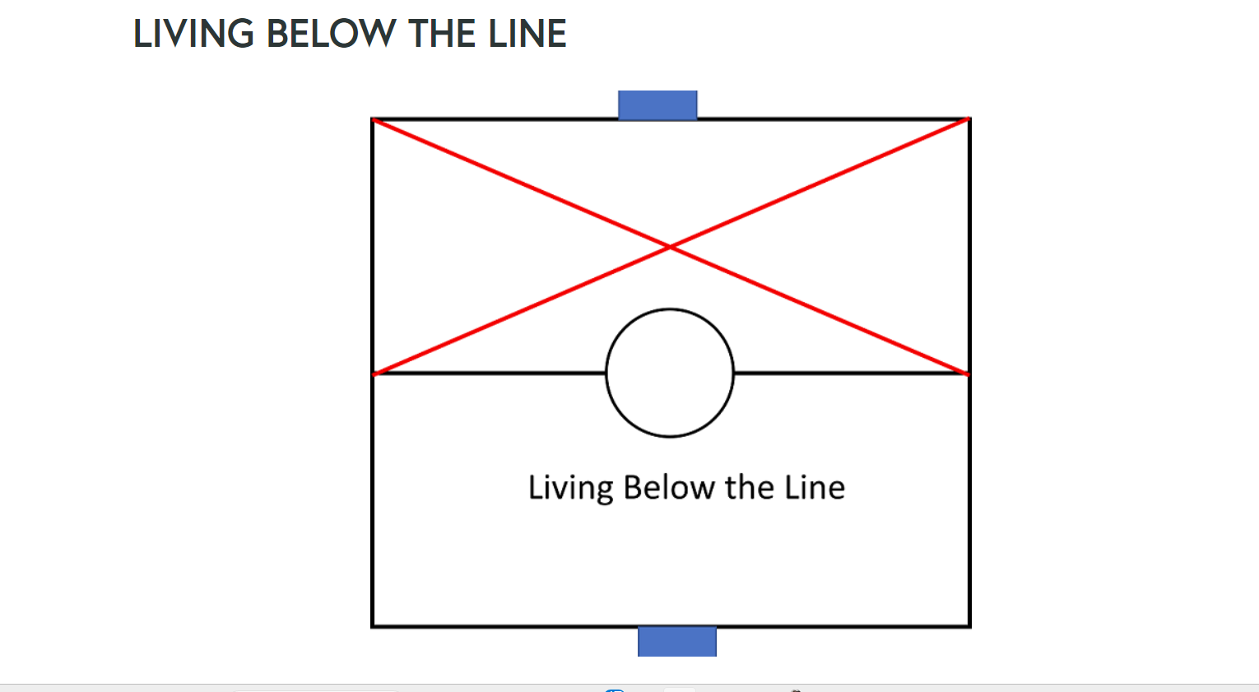

Imagine, as a coach, you are told that your team can only play on the defensive half of the pitch. What would happen to you and your team? What is going to result from such a law? Living below the line is the prison that we all experience, and it prevents us from responding from a place of love, joy and hope.
Living below the line is centered on pride and is manifested in feelings and behaviors like loss, anger, jealousy, gossip, fear, confusion, shame, guilt, blame, drug, or alcohol abuse, physical, verbal or spiritual abuse, rejection and many others. All these ultimately lead toward destruction and death.
Living below the line is the result of our sin and flesh. Most people do not realize that they are living blindly below the line. Satan is a deceiver, and he tries to blind us to this reality. So, these people have been deceived into a false belief that self-righteousness and pride are the true life.
Individual and team performance is limited. There is a lid or a cap as to how far they can perform because inevitably, our flesh and sin get in the way. This is true in all human endeavors, not just sporting teams.
When a coach is living below the line, he/she is going to bring those flesh behaviors to the pitch. The players, who have given the coach the authority role, will then respond to what the coach is telling them, and the lies are passed along to them. This results in players who are resentful, frustrated, unmotivated and self-destructive.
Our only way out is a life surrendered to Jesus. Jesus lived the life of being constantly above the line. He never walked this world in pride but in complete servanthood and humility to God his Father. Breaking free from living below the line can only start in one place - surrendering our life to Jesus. To start our healing, to start drying up our streams of temptation, to open the new reality that God is Love, that God is good, and that God can be our only true trusted one, we must recognize that Jesus is the only one who can save us and ask Him into our heart.
Characteristics and Behaviors of Life Below the Line
Distrust, envy, loss, anger, blame, control, self-centered, self-focused, victimhood, unforgiveness, jealousy, shame, guilt, frustration, gossip, pride, confusion, self-justification, helplessness, self-righteousness, self-loathing, fear, anxiety, addictions, resentment, gluttony, blame, bitterness, lies, strife, sickness, depression, loneliness, possessiveness, narcissism, follow cravings
Where is God?
- God does not care for me
- God does not know I exist
- God will not save me
- God hates me
- God is a god of punishment
- God does not exist
What are the Beliefs?
- I am not unique
- I have no true value
- I have no ordained destiny
- I am helpless
- Watch out for number one
- I am unlovable
- Biblical word has no value
Romans 7:21-25
For I do not understand my own actions. For I do not do what I want, but I do the very thing I hate. Now if I do what I do not want, I agree with the law, that it is good. So now it is no longer I who do it, but sin that dwells within me. For I know that nothing good dwells in me, that is, in my flesh. For I have the desire to do what is right, but not the ability to carry it out. For I do not do the good I want, but the evil I do not want is what I keep on doing. Now if I do what I do not want, it is no longer I who do it, but sin that dwells within me.
2 Thessalonians 2:11-12
Therefore, God sends them a strong delusion, so that they may believe what is false, in order that all may be condemned who did not believe the truth but had pleasure in unrighteousness.
John 8:23-24
He (Jesus) said to them, You are from below; I am from above. You are of this world; I am not of this world. That is why I told you that you will die in (under the curse of) your sins; for if you do not believe that I am he [Whom I claim to be-if you do not adhere to, trust in, and rely on Me], you will die in your sins.
Galatians 5:19
Now the works of the flesh are evident: sexual immorality, impurity, sensuality, idolatry, sorcery, enmity, strife, jealousy, fits of anger, rivalries, dissensions, divisions, envy, drunkenness, orgies, and things like these.
​Ephesians 2:3
Among whom we all once lived in the passions of our flesh, carrying out the desires of the body and the mind, and were by nature children of wrath, like the rest of mankind.
Matthew 6:1
Beware of practicing your righteousness before other people in order to be seen by them, for then your will have no reward from your Father who is in Heaven
Proverbs 11:2
When swelling and pride come, then emptiness and shame come also, but with the humble (those who are lowly, who have been pruned or chiseled by trial, and renounce self) are skillful and godly Wisdom and soundness.
John 14:6
I am the Way, the Truth and the Life. No one comes to the Father except through me.

Prayer
Dear Lord, you have opened my eyes to a new reality. Lord, I have been living life below the line and I have been in rebellion, I have chosen my own way, I have been living my life as I see fit. I see now that this doesn’t produce anything good or long lasting, that my pride along with my insecurity drive my decisions and my responses. Thank you for showing me this today. Amen.

